|  |  |  |  |  |  |  |  |  |
| --- | --- | --- | --- | --- | --- | --- | --- | --- |
| Forecast Values | |  |  |  | Compiler Engine Information | | |  |
|  |  |  |  |  |  |  |  |  |
| Stand ID: | | 763406 | | | GYPSY Model: | | 2009-May-21 | |
| Stand Type: | | Natural |  |  | Application: | | 20100713p | |
| Stand Age: | | 38 | years |  | COM DLL: | | 20100329b35 | |
| Spatial: | | NO |  |  |  |  |  |  |
| BA adjusted: | | YES |  |  |  |  |  |  |
|  |  |  |  |  |  |  |  |  |
| Input Data | |  |  |  |  |  |  |  |
|  |  |  |  |  |  |  |  |  |
| Species | | totage | topht | den | ps | ba | utilization | |
| AW |  | 33.0 | 5.05 | 167 |  | 2.6 | 13/7/30 | |
| SB |  |  |  |  |  |  | 15/10/30 | |
| SW |  | 38.0 | 5.05 | 113 |  | 1.77 | 13/7/30 | |
| PL |  | 27.0 | 5.05 | 98 |  | 1.53 | 13/7/30 | |
|  |  |  |  |  |  |  |  |  |
| Calculated Attributes | | |  |  |  |  |  |  |
|  |  |  |  |  |  |  |  |  |
| Species | | bhage | y2bh | si_bh | si_t | n0 | sdf | psi |
| AW |  | 24.2 | 8.8 | 8.3 | 7.3 | 168 | 165 |  |
| SB |  |  |  |  |  |  |  |  |
| SW |  | 23.5 | 14.5 | 9.2 | 7.0 | 113 | 113 |  |
| PL |  | 16.6 | 10.4 | 11.2 | 9.6 | 98 | 98 |  |

Tesera Gypsy

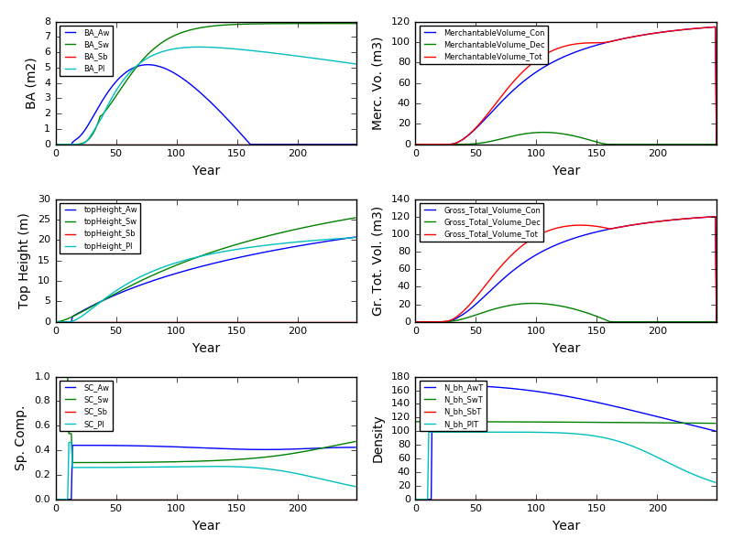

Excel Gypsy

